Simple Searches Using the CSR

These instructions will show you how to log in to the CSR and undertake a basic search.

- Double click on CSR Putty icon. This will open the CSR.

- The CSR Login Prompt will appear in the window.

- Type your CSR login – this will usually be intake

                - Do not type the login in upper case

- Press the return key

                - N.B. If you make a mistake when typing the login you cannot backspace or overtype. Press return again and wait for login prompt.

- At the password prompt, type your password – this will usually be intake

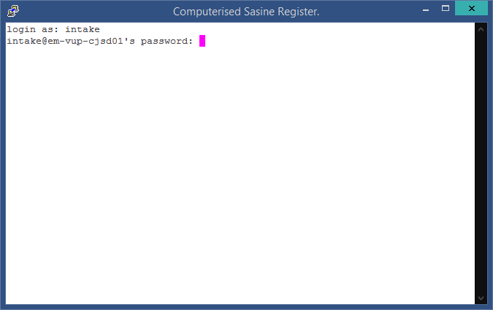

- Once you have passed this screen, you will be presented with the CSR Login screen.

- Type your USER ID

                - NB: The number keypad on the right hand side of the keyboard cannot be used with CSR.

- Press the down arrow on the keyboard once to move the cursor into the Password field.

- Type your CSR password and press the Enter key NB: NOT the return key

- Your menu should look like this

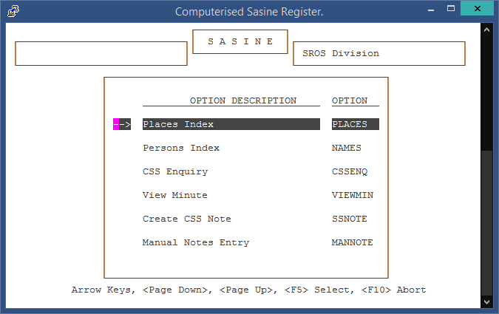

Searching the Places Index

Select the Places Index by clicking F5 – it will take you to this screen

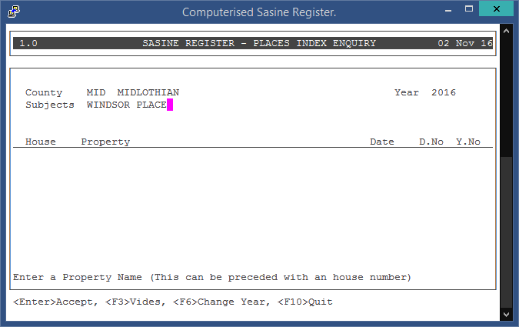

Enter County and place name. You will need to use the function keys (at the top of your keyboard) to navigate the CSR. Refer to the quick reference guide for an explanation of the function keys.

Searching the Persons Index

Press F10 to go back to the main menu

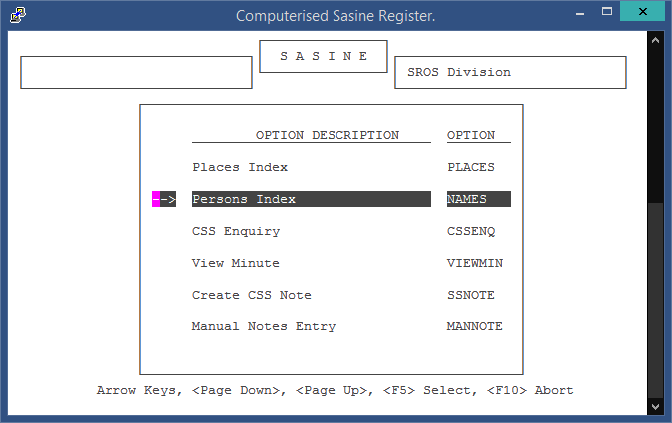

Press the down arrow key to highlight the persons index

Press F5 to select the persons index

The same function keys are used with this option as with the Places Index.

CSS Enquiry

Press F10 to go back to the main menu

Highlight and select the CSS enquiry option

This allows you to view a computerised search sheet.

- Enter details of the County and the Search Sheet Number.

- Press the <Enter> Key.

- If a CSS exists the system will display the sheet.

Closing down the CSR

- Press the F10 key until you get back to the login screen

- Press F10 one more time

- The CSR window will close

Unlocking a User from CSR

If you are unable to log in to CSR because your username is locked, then take the flowing steps:

- At the login prompt, type “useradm”
- Press the Return key
- Type “useradm” again when presented with the password prompt
- At User ID, type "USERADM"
- Press the Return key twice
- Password “ADMIN”
- Press Enter key to accept
- Press F5 key to select “Unlock User”
- Press the Return key to select “Unlock”
- Enter the User ID that is locked
- Press Enter
- The User Name for that User ID – CSR should say “Lock Removed” for two seconds or so
- Arrow right to highlight “Exit” and press the Return key to exit
- “F10” all the way out

